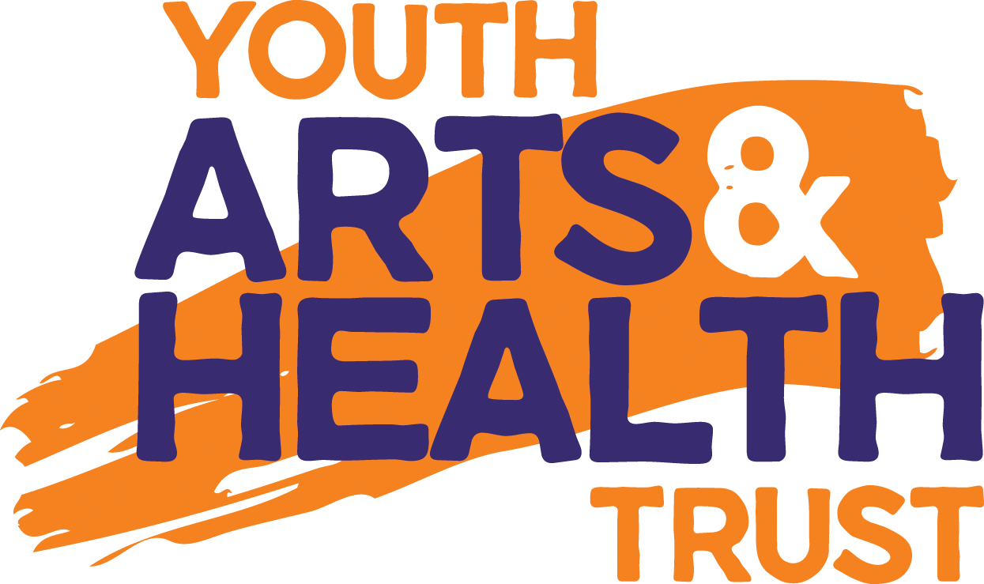

Arts Therapy Referral Form and Risk Assessment

for face to face or online sessions

Date of referral:
About the young person
Name:
Date of birth:
Their current age:
Their preferred pronouns:
Address/ or addresses if moving between two addresses:
Name of parent/carer with parental responsibility:
Email of parent/carer:
Phone numbers:
Contact details for parent/carer:
(two methods please)
GP name, address and telephone:
Is the young person in education, employment or training? If so - please give details:
About the referrer
Name:
Organisation and/or role in relationship with the young person:
Address:
Email:
Phone numbers:
About the referral
Has this referral been made with the young person? | Yes [ ] No [ ]  Notes (if needed):
Reasons for referral:
(please continue on separate sheet as needed)
What would the young person like to get out of any arts therapy sessions?
Does the young person have any specific mental health difficulties, learning disabilities or conditions?
Please give details:
Does the young person have a formal diagnosis?
Please give details:
Please give details of any medication the young person is taking or carries with them related to any medical condition:
Does the young person have a history of support, from CAHMS? Please give details and someone we can contact to discuss:
Has the young person had any previous experience of therapy or counselling? Please give details:
Does the young person have any communication or accessibility needs?
Please give details:
Does the young person have any special interests, skills or aspirations you would like us to be aware of?
Please give details:
Does the young person have any preferences at this stage? (E.g. group or individual therapy, face to face or online sessions, a particular project you have heard about).
Does this young person have access to a phone with camera, tablet with camera or computer with camera? Please note if this is a barrier we will try to help with this.
Does this young person have access to the internet?
Anything you would like us to be aware of?
Please give details:
Finances
Does the young person have access to funding through social services/Early Help/Adoption Support Fund/DLA/school/pupil premium/local provider/privately paying/other?

Please give details:
Please indicate the total family income band (if you would like to be considered for grant and donation funded sessions). | Under £20,000 pa [ ]  Between £20,000-£30,000 pa [ ]  Between £30,000-£40,000 pa [ ]  Between £40,000-£50,000 pa [ ]  Over £50,000 pa [ ]  (Income to include any benefits)
Consent
Does the young person give consent to this referral? | Yes [ ] No [ ]
Does the parent/carer with parental responsibility give consent? (if child under 18) | Yes [ ] No [ ]
Does the young person give consent for us to contact their GP/parent/other services as necessary? | Yes [ ] No [ ]  Notes (if needed):
Please list 1 or 2 preferred contacts the young person is happy for us to contact following sessions should we need to. | Name:  Relationship:  Contact telephone numbers:  Name:  Relationship:  Contact telephone numbers:

Arts Therapy Referral Initial Risk Assessment

Date completed:
Name of person completing:
Who completed with:
Name of young person:
Risk Assessment
Self-harm:
Is the young person currently self-harming? | Yes [ ] No [ ]  Notes:
Does the young person have a history of self-harming? | Yes [ ] No [ ]  Notes:
Self-neglect:
Does the young person have current difficulties with  self-neglect? | Yes [ ] No [ ]  Notes:
Does the young person have a history of self-neglect? | Yes [ ] No [ ]  Notes:
Abuse and exploitation:
Is the young person currently experiencing abuse or exploitation? (e.g. abuse, bullying) | Yes [ ] No [ ]  Notes:
Does the young person have a history of abuse or exploitation? | Yes [ ] No [ ]  Notes:
Suicide:
Does the young person have current suicidal thoughts? | Yes [ ] No [ ]  Notes:
Does the young person have current suicidal plans? | Yes [ ] No [ ]  Notes:
Does the young person have a history of any suicidal thoughts, plans or attempts? (Please give dates and details of any attempts) | Yes [ ] No [ ]  Notes:
Risk to others:
Does the young person have a history of being a risk to others? (e.g. aggressive behaviours, arson) | Yes [ ] No [ ]  Notes:
Does the young person have any communication or accessibility needs?  Please give details: | Yes [ ] No [ ]  Notes:
Does the young person have any preferences at this stage? (E.g. art or dramatherapy). | Yes [ ] No [ ]  Notes:
Other risk factors:
Does the young person have a history of drug or alcohol abuse? | Yes [ ] No [ ]  Notes:
Does the young person have a history of homelessness? | Yes [ ] No [ ]  Notes:
Does the young person have a history of disintegration with significant attachment figure?  (e.g. history of adoption, unhealthy relationship with mother/father/caregiver) | Yes [ ] No [ ]  Notes:
Other risk factors not identified above: | Notes:

Thank you for completing these forms. Please note you may be asked to
complete an additional consent form once an offer of sessions is made.

Signed by referrer:________________________________ Date:______________

Signed by young person:___________________________ Date:______________
(if possible)

We prefer form to be emailed to us, please send to
info@youthartsandhealth.org
If emailing is not possible, please print and post to YAHT Referrals, Youth Arts & Health Trust, YES Centre, 22 Cathedral Yard, Exeter, EX1 1HB marking the envelope ‘private and confidential’.

*IMPORTANT*

Please password protect this referral form and any accompanying documents wherever possible.

Instructions for how to do this on Word-

- Open the Word document
- Click on File
- Click on Info
- On the right side, click the Protect document menu
- Select the Encrypt with Password option
- Type a password to protect the document
- Click the OK button
- Retype the password

The document will now be password protected with the password of your choice. Please send the password to info@youthartsandhealth.org in a separate email or text to 07967 188 493 with the initials of the referrer.

